TEACHING STAFF
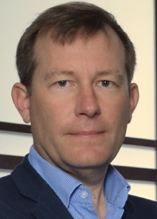 | Anthony CHAMBOREDON, Founder & Director  Paris Cité University  Anthony.Chamboredon@u-paris.fr  * Comparative law methodology
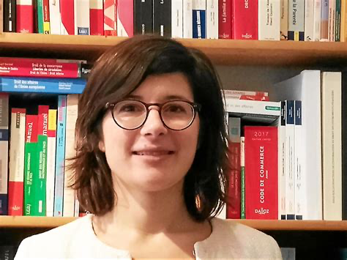 | Laure de SAINT PERN  Paris Cité University  laure.desaintpern.droit@gmail.com  * Comparative law methodology & Family Law
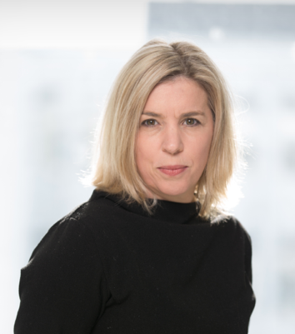 | Marie Eve Arbour  Laval University, Canada  Marie-Eve.Arbour@fd.ulaval.ca  * Contract Law I
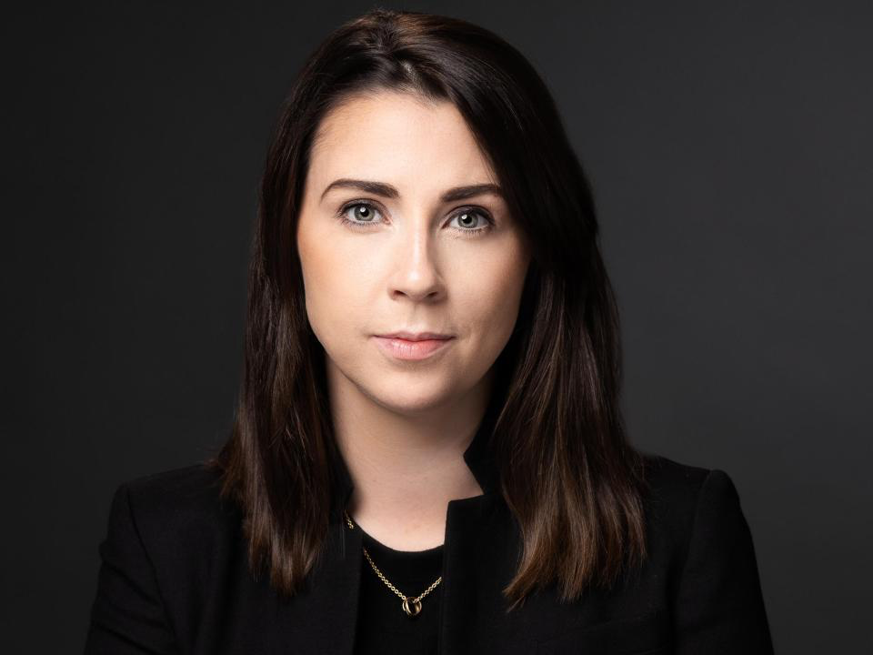 | Róisín Áine Costello  Dublin City University (DCU)  roisin.ainecostello@dcu.ie  *Tort Law I
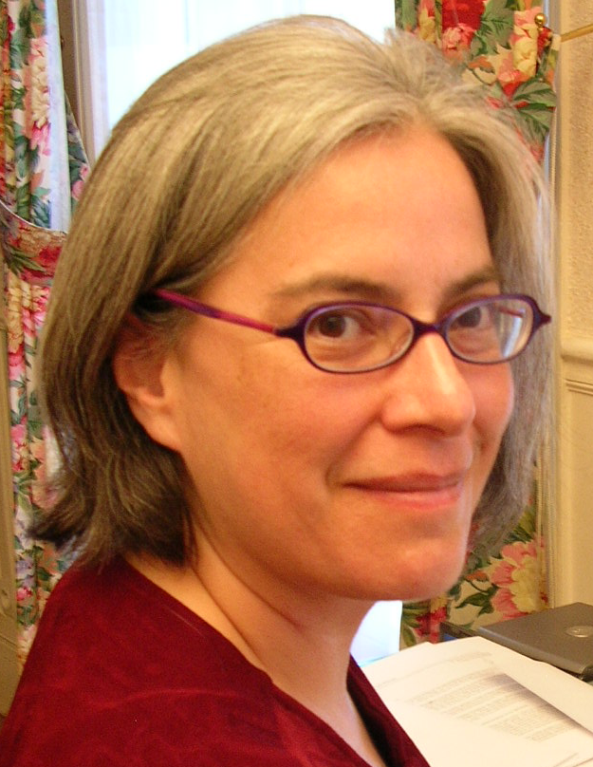 | Ileana PORRAS  Miami University School of law, USA  J.D. 1989, Harvard Law School  iporras@law.miami.edu  http://www.law.miami.edu/facadmin/iporras.php  * Property law and theories of property
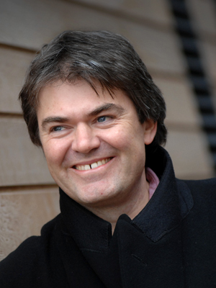 | Gary WATT  Warwick school of law, UK  Gary.Watt@warwick.ac.uk  http://www2.warwick.ac.uk/fac/soc/law/staff/academic/watt/  * Trust
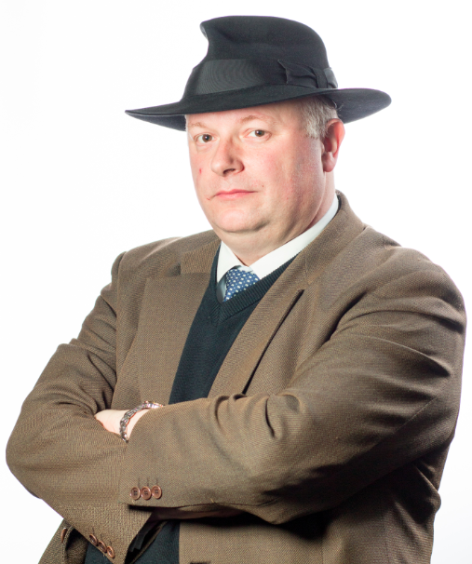 | Eoin O'DELL  Trinity College Dublin, Eire  odelle@tcd.ie  http://www.tcd.ie/Law/EoinODell/  * Restitution & Equity
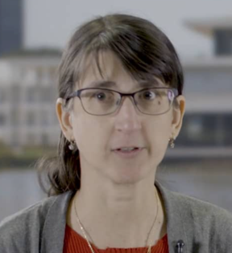 | Audrey GUINCHARD  Essex university law school, UK  abguin@essex.ac.uk  * Criminal Law

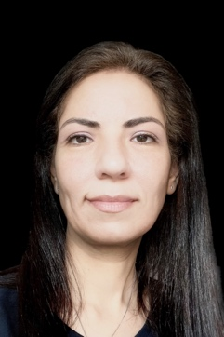 | Yasmine SADEK  Head of Permanent Control and Compliance, National Australia  yasmine.sadek@eu.nabgroup.com  * Business Law I – Corporate Law
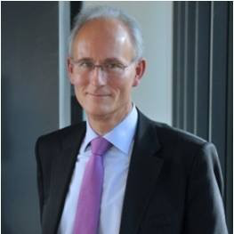 | Stephen DALE (UK)  stephen.h.dale.france@gmail.com  * Business Law III – Tax Law, VAT and Customs, Local Taxes and environmental taxes
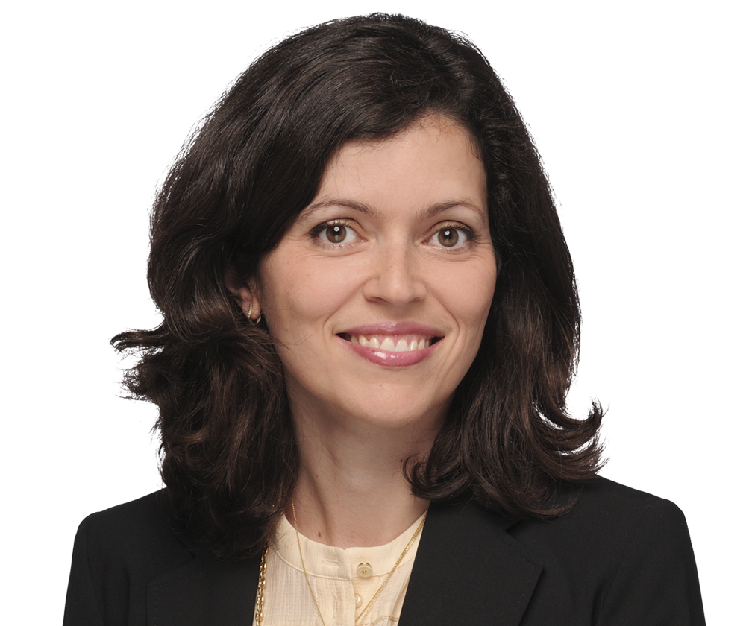  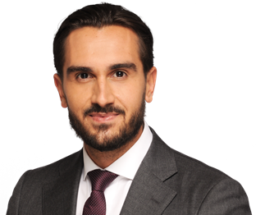 | Alexandra VAN DER MUELEN (Counsel)  Alexandra.VanDerMeulen@freshfields.com  Quentin HERRUEL (Associate)  Quentin.Herruel@freshfields.com  *Business Law IV – International arbitration
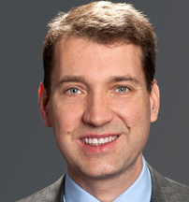 | Robert M. FLANIGAN  rflanigan@mayerbrown.com  *Business Law III - Bank and Finance
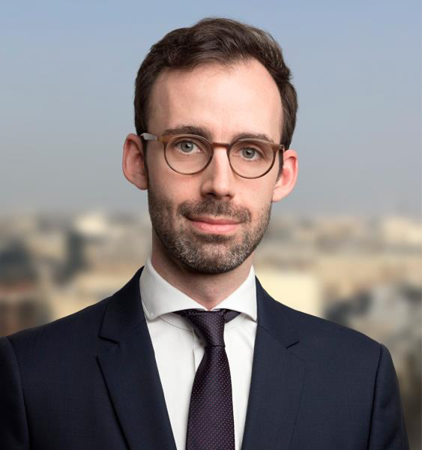 | Patrick DUPUYS  patrick.dupuis@skadden.com  * Business Law II – Merger & Acquisitions

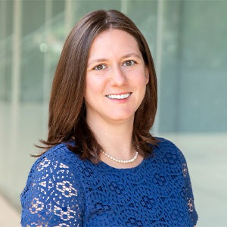 | Laura NAPOLI COORDES  Arizona State, USA  Laura.Coordes@asu.edu  * Contract Law II
Lara Khoury

Mc Gill University, Canada
lara.khoury@mcgill.ca

*Tort Law II – Medical Liability

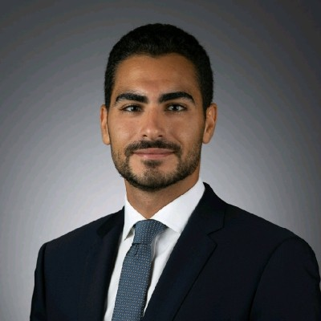 | Zyad LOUFTI  PHD Cornell University  yadloutfi@outlook.com  * Property Law II – Intellectual property
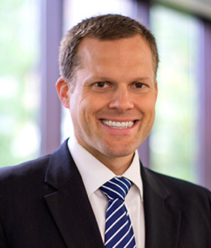 | Forrest HANSEN,  Bringham Youth University, Utah, USA  hansenf@law.byu.edu  * Comparative Law I – Comparative Constitutional Law
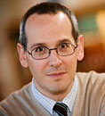 | Mitchel LASSER  Cornell University, USA  ml355@cornell.edu  http://www.lawschool.cornell.edu/faculty/bio.cfm?id=41  * Comparative law II – Comparative judicial decision making
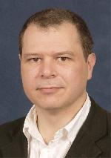 | Scott VEITCH  University of Hong Kong, China  veitch@hku.hk  http://www.law.hku.hk/faculty/staff/scott_veitch.html  *Comparative law III – Scott Law
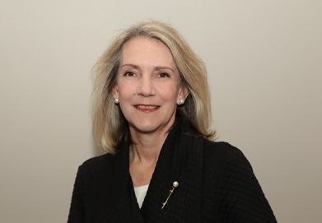 | JUANITA M PIENAAR  Stellenboch University, South Africa  jmp@sun.ac.za  * Comparative Law IV: South African Law
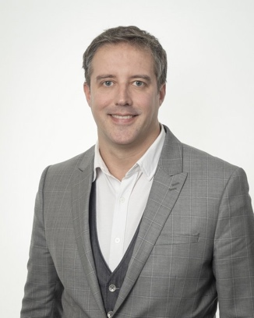 | David GILLES  Sherbrooke University  David.Gilles@USherbrooke.ca  *Comparative Law V – Canadian Law

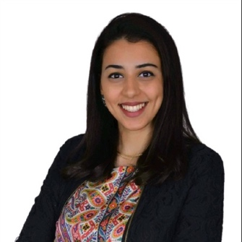 | Nada ABOUELSEOUD  Paris Cité University  nadabouelseoud@gmail.com  * Legal English & Moot court

